Please complete this form and return it to:
Wilton Parish Church

Concert Charges
2025
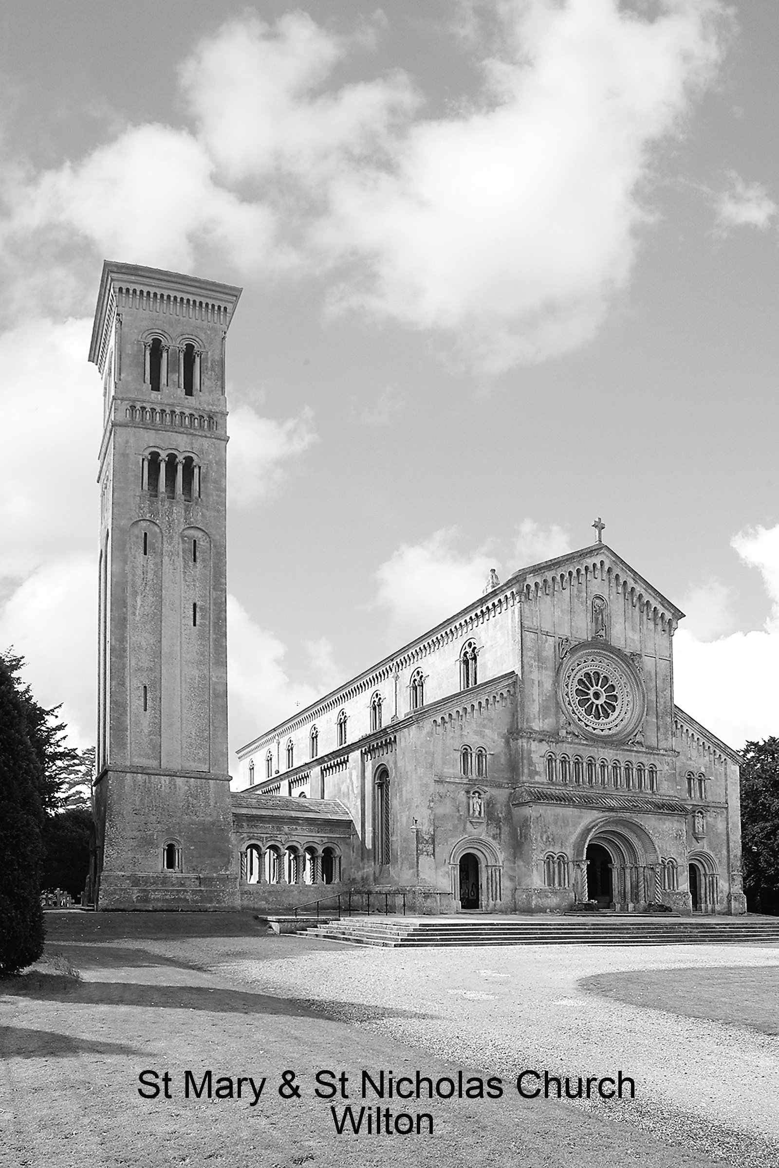
The Parish Secretary,
The Parish Office,
WMSET Centre,
West Street,
Wilton,
SP2 0DL
Telephone: 01722 742393

Name of Organisation:
Nominated Contact:
Name: Position:
Address:
Daytime telephone no: |  |  |  |  |  | e-mail address:
- Type of Function: e.g. Choral Concert |  |  |  |  |  |  |  |  |  |  |  | Official Use Only:
- Date of Function
- Times required: (up to 4 hours total)  Performance:  Main rehearsal |  | From |  |  |  |  |  | To: |  |  |  | £350 - basic fee  (Includes access,  and 1 steward  at the event)
- Additional Requirements: Please tick the boxes below which apply:
Heating (if required) £215
Additional Rehearsal Time
(£60 per hour)
Use of additional lighting
(£40)
Use of Organ
(£100)
Use of Piano
(£55)
Use of Gallery (Additional Steward)
(£65)
Interval Bar requested:  - Arranged by concert organiser.  (£25 fee)  Or b) Provided by church.  (No charge – proceeds to church) |  |  |  |  | NB - if money changes hands for alcoholic drinks a Temporary Events Notice is required.
Approximate Numbers Attending  (if known) |  |  |  |  |  |  |  |  |  | Total Cost
- I agree to abide by the Terms and Conditions of Use (a copy of which I have received and have read).
I undertake to leave the church clean and tidy and to return any furniture moved to its original location.

 |  |  |  | Signature: |  |  |  |  |  |  | Date:

Cheques payable to “Wilton PCC”
or BACS payments Wilton PCC (St Mary & St Nicholas Church Sort Code: 30-97-41; a/c no: 02981710

Wilton Parish Church - Facilities and Conditions

Information:

There is seating (fixed pews) for approximately 375 people – including the gallery.
If additional seating is required chairs may be placed at the rear of the pews
provided a clear exit route is maintained at all times.

The church has a Schiedmayer Baby Grand Piano and a fine 3-manual Hill Organ.

There is a single toilet and limited facilities for refreshments in the “south” porch.
Additional facilities, including an “Accessible toilet” may be arranged at the WMSET Centre (adjacent), or Community Centre (Opposite).

A small Car park for approx 15 cars. is available at the side of the church.
(The Community Centre has its own PRIVATE Car Park. Contact Miss Dawn Humphries: Tel. 01722 744859)

Additional lighting, which conforms to current safety legislation, may be introduced at the hirers own expense.
An additional charge of £35 will be made to cover church costs.

The church may be able to provide a “bar” for interval drinks, retaining all proceeds.
Please advise us as early as possible if required.
Alternatively, if you prefer to provide your own, a levy of £25 will be charged. You will also need to obtain a Temporary Events licence if money changes hands for alcohol.

Conditions of use:

- All applications for use of the church should be made on the form provided.
- Where possible charges should be paid in advance of the event and in all cases not more than 14 days afterwards.
- The PCC reserves the right to refuse any bookings or to attach additional conditions where need arises.
- If the organ is to be used an additional fee of £75 is levied to assist with the considerable cost of maintaining the instrument. The organist, Dr. Nigel Allison, should be contacted to arrange practice time. (email: nallison121@gmail.com)
- No fixed furniture should be moved under any circumstances.
- The Ravenna marble pavement at the floor of the Chancel steps should be protected as much as possible. Under no circumstances should the piano be placed on the marble.
- No food or drink – other than bottled water - may be taken into the Chancel (choir stalls). Access is not permitted to the Sanctuary area around the Altar.
- Users of the church must take all reasonable precautions to ensure the safety, security and maintenance of the church building, its contents and persons using the same.
- The applicant and persons engaged by him/her are NOT covered by any insurance effected by the Church Council and must make their own arrangements for any such insurance. The users undertake, by signing the prescribed form, to indemnify the PCC in respect of loss, damage (except in fire and explosion) or injury costs arising from this hiring. The PCC does not accept responsibility or liability in respect of damage to or loss of any property or anything whatsoever placed or left on the premises or by any person for the use or purpose of the user or by any persons attending the premises during the period of this hiring.
- The exits must be kept clear at all times.
- If refreshments are served, the church must be left clean and tidy (a vacuum cleaner is available) and all rubbish taken away.
- When setting up for a rehearsal or performance. Please be sensitive to the needs of any parishioners/others visiting the church to pray – some of whom may be distressed.
- A church representative will be available to open and close the church at the start and finish of performances and/or rehearsals. They will not be expected to assist with ticket/programme sales etc.
- Where the gallery is used, access is not permitted to the front row of pews.
Please confirm your acceptance of these Conditions by signing the attached form. Thank you for your cooperation in helping us to preserve this unique building!

