The Parish of Wilton with Netherhampton and Fugglestone

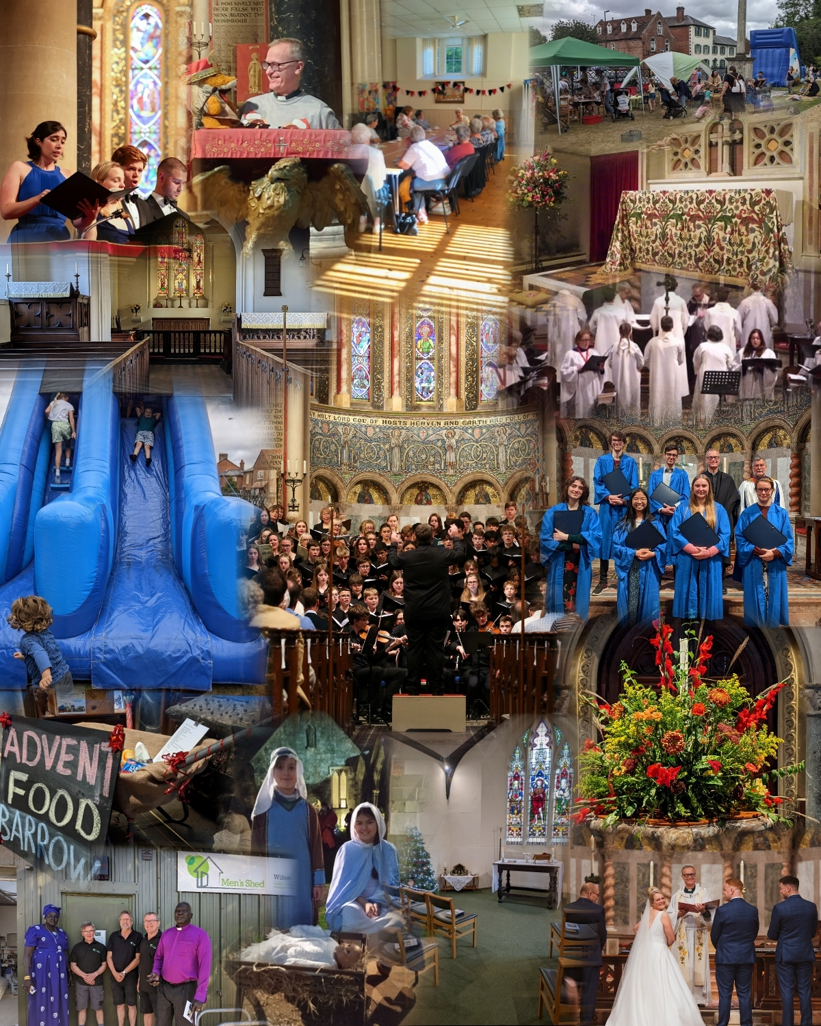

ANNUAL REPORT 2022
The Parish of Wilton with Netherhampton and Fugglestone

ANNUAL REPORT 2022

When planning activities for the year, the incumbent and PCC have considered the Commission’s guidance on public benefit and the specific guidance on charities for the advancement of religion. We strive to enable parishioners to explore and develop their spiritual awareness and to live out their faith, by means of prayer and worship, Bible study, ethical discussion, and provision of pastoral care to all sections of the community. The work of all three churches is summarised on the parish website (www.wiltonparish.co.uk ) and promoted via the Parish Church and “Wilton Chat” (community) pages of “Facebook” and through the quarterly Parish Newsletter, distributed to all dwellings in the Parish.

The PCC aims to provide public worship appropriate to the varied needs of the inhabitants of the Ecclesiastical Parish. Where practical this includes ecumenical cooperation with the local Baptist congregation and members of other Christian denominations living in Wilton.

The clergy seek to respond to all requests for the “Occasional offices” of the Church – Baptisms, Marriages and Funerals from those living in the Ecclesiastical parish, or with a legitimate connection with any of our churches and to provide appropriate preparation and pastoral care.

We seek to foster a sense of community within the town of Wilton through the provision of social activities and active involvement in other local organisations.

To facilitate this work we strive to maintain the fabric of our church buildings in good order, taking due note of the recommendations included in our Quinquennial Inspections.

In December 2009 it was agreed that the PCC would discontinue its policy of making annual grants to specific charities and would instead encourage individual Church members to support such charities as far as they are able. In addition, the PCC nominated a quarterly Charity – for which donations were invited at Coffee after the principal service each Sunday. In addition the congregations at Wilton and Netherhampton have facilitated donations of food and household consumables for the Trussell Trust, Alabaré Christian Care and The Salisbury Women’s Refuge. An “Advent Food Barrow” was placed in the Parish Church during December, to raise awareness of the increasing demands made on the local Foodbank.

The PCC seeks to make provision for regular public worship, across all three churches, as well as a Trust-owned Chapel in Wilton. The former Parish Church, “Old St. Mary’s”, is under the care of the Churches Conservation Trust and is used for occasional worship.

St Peter’s church was largely closed as the future of the building remained under consideration. A group of volunteers undertook a thorough spring clean of the building, ahead of a special service for St Peter’s day and also the first wedding to be held in the church for a quarter of a century. The funeral of the late Bill Hewlett, Deputy Warden at St Peter’s for 50 years, was held at the church in July.

Services were held in at least one of the other two churches every Sunday, with a video recording of the principal service at Wilton being made and posted online - via YouTube, the Parish website and the Parish Church Facebook page.
Audio CDs of some services continued to be distributed each month, to a number of house-bound parishioners without internet access. .
The Parish Clergy were assisted in leading worship by two Lay Worship Leaders, Christine Lawson and Tim Purchase; and by Canon Sue Wallace, Canon Tom Clammer and Canon Michael Goater. The Revd Andrew Poppe moved to Wilton, following his retirement, and was given “permission to officiate” from October.
On Trinity Sunday, 12th June, Canon Chris Savage presided and preached at the Eucharist for the last time, before stepping back from public ministry. The Rector expressed his thanks for his ministry in this parish, to warm applause from the congregation.
Also in June, Canon Sue Wallace moved to a new post at Truro
Cathedral.

On 19 June, a number of parishioners attended Salisbury Cathedral for the Inauguration Bishop Stephen Lake, as Bishop of Salisbury. We were pleased that his first official engagement as Bishop was a visit to our Primary School.

After Easter, the Rector resumed weekly whole-school worship at the Church Primary School and facilitated a number of class visits to the Parish Church.
In December, Children, Parents and Staff worshipped together in the Parish Church for the first time since 2019. This was also the first “Christingle Service” to be held there since 2019.

Our Lay Pastoral Assistants continued with regular home visiting, and services were again offered for small groups at Olivier Place and Bulbridge. Visits to hospitals and Care Homes were also resumed. The Pastoral Ministry team continued to meet each month, to review current circumstances and to communicate particular concerns.

At the Annual Meeting in May, Andy Tyrer stepped down as Churchwarden and Richard Norris was appointed, alongside Julian Lyne – Pirkis. Ann Hindley was reappointed as Deputy Warden, with responsibility at Wilton, and Katie Ray and Philip Matthews reappointed as Deputy Wardens for St Catherine’s and St Peter’s Churches respectively.

We were well served by a hard-working team of sidespersons and by Altar-servers, readers, intercessors, musicians, brass polishers, flower arrangers, and coffee -makers –
all of whom played a part in restoring some sense of shared “ownership” of our worship, after the constraints of the previous two years. We retained our team of Technical assistants, who were also able to give support at other events.

The Rector, the Revd Mark Wood, completed a “training the trainers” Safeguarding Course, to enable him to provide face-to-face Safeguarding training for Parish volunteers. Our Parish Safeguarding Officer continued to give regular guidance, and the PCC reviewed and updated the parish’s Safeguarding Policy, in line with Diocesan and Church of England guidelines.

The Director of Music at Wilton, Dr. Nigel Allison, was ably assisted by Edward Akers and the Rector continued to direct the “Schola Cantorum”. Three young singers left to begin University Studies – one with a Choral Scholarship to The Queen’s College, Oxford –
and five new singers were recruited, singing their first service in September.
Organ playing at St Catherine’s was provided by William Alexander and Dr. Fiona Allison.

Special Church Services included Good Friday services and Easter Services at both Wilton and Netherhampton, including the 6.30 “Easter Liturgy” at Wilton.

The Platinum Jubilee of her late Majesty Queen Elizabeth II was celebrated with special services at both Wilton and Netherhampton, and the congregations of St Catherine’s were active in supporting the village’s Street party.

In September, the planned celebrations of St Edith’s Day were eclipsed by the national mourning for the late Queen: special liturgies were used in both churches, and the town’s Book of Remembrance was kept in the Parish Church for the duration of the official period of mourning. The Mayor of Wilton led the Proclamation of the new king, from the steps of the Parish Church, accompanied by the Rector, members of the Town Council, Lord Pembroke and Lord Margadale, Deputy Lieutenant of Wiltshire.

Harvest Thanksgiving was celebrated in both churches, and donations of food were received for distribution through local charities.

Singers from a number of choirs combined to sing Choral Evensong for the “Dedication Festival” at Wilton, and the Patronal Festival at St Catherine’s was celebrated with a Gift-Day service on 27 November.

Remembrance services in both churches were well attended.
In addition to the established representation from the uniformed Youth Organisations, Royal British Legion, Town and County Councillors; armed forces and Cadet Corps; we were joined for the first time by Forces Veterans from Wilton’s Veterans Centre, Erskine House.

The Christmas Carol service at Netherhampton was, again, followed by refreshments in church itself. There was also a celebration of Holy Communion on Christmas Day.

Both choirs were able to sing together at Wilton’s Carol Service, and were joined by a small brass ensemble. On Christmas Eve the afternoon “Crib Service” was re-introduced, and “Midnight Mass” was celebrated. Sung Eucharist was celebrated on Christmas Morning.

A number of concerts were held in the Parish Church.
In March, The Bath Chorus marked their 75th anniversary with a first visit to Wilton. The church’s distinctive “Italianate” architecture provided an appropriate backdrop for their performance of Rossini’s “Petite Messe Solonelle”.

On Palm Sunday afternoon, the Villiers Quartet provided another “first” – with a world premiere performance of Ailsa Dixon’s “Variations on Love Divine”.

May saw both a return of Cambridge Renaissance Voices, for a concert of music by Italian Renaissance Composers, and also a large-scale performance of Mozart’s Requiem with singers and instrumentalists drawn from schools in Salisbury, Birmingham, Reigate, and Stratford on Avon.

In June we welcomed the Cowbridge Male Voice Choir, for their first visit and a “charity fundraiser” in support of a local family in need of help with specialist medical care.

A planned concert by the Salisbury Chamber Chorus, in July, was cancelled due to Covid infections within the group, but happily they were able to return in December for their Christmas Concert.

We welcomed a new “Youth Volunteer” in December –
completing his “Bronze Award” of the Duke of Edinburgh Award Scheme – to assist at Church services and public events, and to provide practical help with preparations and tidying of the Parish, and with delivering newsletters.
This was the seventh such volunteer since the parish first engaged with the scheme in 2019.

Parish Groups continued to meet regularly, including the men’s group, “Grapevine”, the seniors’ group “Young at Heart” and the Mothers’ Union.

“Spurgeons UK” continued to work with the parish to run a weekly parents and toddlers group, known as “The Hive”; and, in August, to run a Family Activity Day in the grounds of the Parish Church attracting a very large number of local families.

2022 saw a welcome increase in the number of visitors to the Parish Church, and our team of “Church Guides” was reformed and coordinated by The Revd Janet Mudgride.

Pastoral Offices
In 2022, parish clergy officiated at 12 Baptisms, 12 weddings and 17 funerals.
(In 2021 - 9 baptisms, 6 weddings and 14 funerals were conducted.)

Community
Church-members continued to volunteer with other community groups and organisations, including Wilton Community Centre, Wilton Public Library, Alabaré Christian Care, Riding for the Disabled and Salisbury Street Pastors.

A number of church-members served as Trustees for other local charities.
These included the almshouses at St John’s Priory and St Giles’ Hospital and three separate Educational Trusts.

As Trustees of the Wilton Middle School Educational Trust, the Rector and Churchwardens contributed further significant grants to local schools, and other groups and individuals.

Some forty volunteers delivered the Parish Newsletter, to all dwellings in the parish, in March, June, September and December.
Costs of production were met from advertising charges.

In December the Wilton “Tree-lighting event” was held, in the Market Square.
The Rector was assisted, in presenting the Nativity Play, by the Revd Rachel Stacey, Minister-in-training at Wilton Baptist Church. Year 6 children from Wilton Primary School were joined by members of the Cubs and Brownies. The Parish Church provided a stall – selling Cards, Jigsaws, and local crafts in support of parish funds.

Buildings
The heating system at the Parish Church was renovated and recommissioned in March, some five months after a major failure. The temperature within the church was lifted gradually
allow fabric and fixtures to adapt.

Extensive repairs to the organ’s electrical control system were undertaken in September, including the replacement of all wiring between the console and the main organ case.

No other significant works were undertaken in 2022 and there was no notable deterioration to any of the churches.

In November, the PCC endorsed proposals for repairs to the porch roof, doors and rain goods and to the damaged vestry doorframe at St. Catherine’s.
These were then submitted to the Diocesan Advisory Committee for approval.

In November, a “break-in” through the church’s central porch, and a further attempt to gain entry through the cloisters, led to a review of security at the Parish Church.
Thankfully very little damage was caused.
The Parish Office is sited in the WMSET Centre, adjacent to the Parish Church, and leased from the Wilton Middle School Educational Trust.

