The Parish of Wilton with Netherhampton and Fugglestone
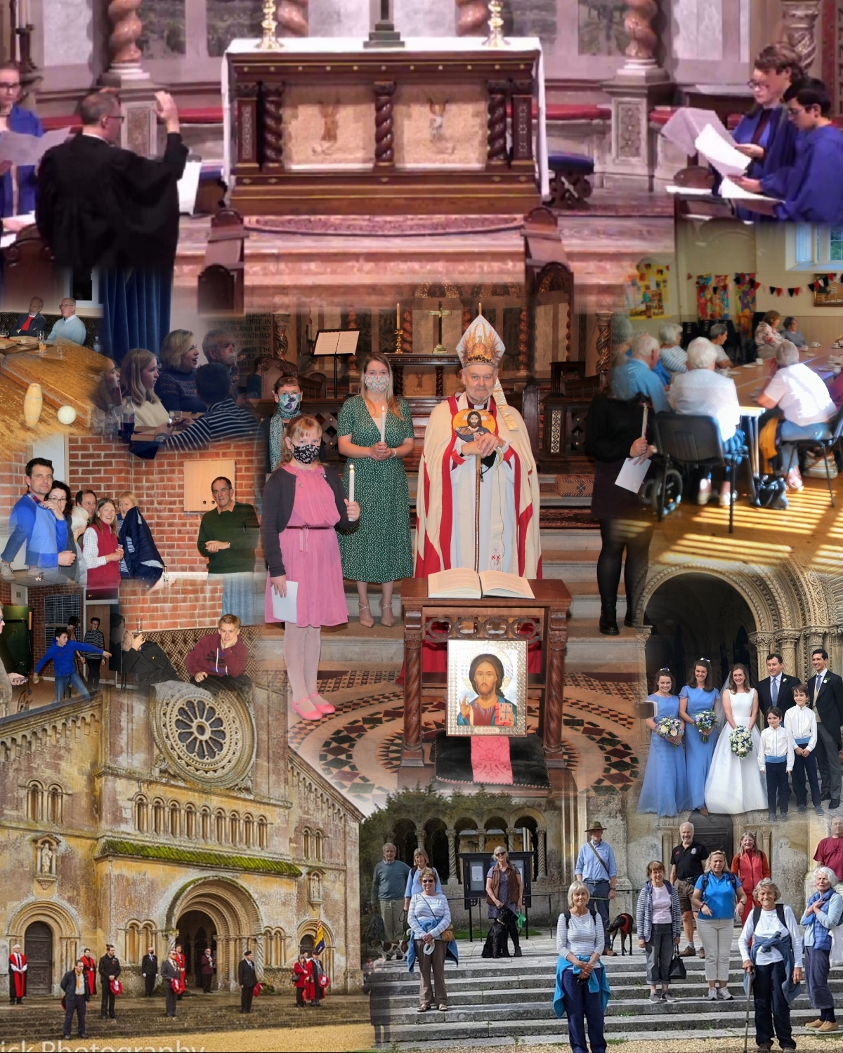

ANNUAL REPORT 2020

The Parish of Wilton with Netherhampton and Fugglestone

ANNUAL REPORT 2020

When planning activities for the year, the incumbent and PCC have considered the Commission’s guidance on public benefit and the specific guidance on charities for the advancement of religion. We strive to enable parishioners to explore and develop their spiritual awareness and to live out their faith, by means of prayer and worship, Bible study, ethical discussion, and provision of pastoral care to all sections of the community. The work of all three churches is summarised on the parish website (www.wiltonparish.co.uk ) and promoted via the Parish Church and “Wilton Chat” (community) pages of “Facebook” and through the quarterly Parish Newsletter, distributed to all dwellings in the Parish.

The PCC aims to provide public worship appropriate to the varied needs of the inhabitants of the Ecclesiastical Parish.
Where practical this includes ecumenical cooperation with the local Baptist congregation and members of other Christian denominations living in Wilton.

The clergy seek to respond to all requests for the “Occasional offices” of the Church – Baptisms, Marriages and Funerals from those living in the Ecclesiastical parish, or with a legitimate connection with any of our churches and to provide appropriate preparation and pastoral care.

We seek to foster a sense of community within the town of Wilton through the provision of social activities and active involvement in other local organisations.

To facilitate this work, we strive to maintain the fabric of our church buildings in good order – taking due note of the recommendations included in our Quinquennial Inspections.

In December 2009 it was agreed that the PCC would discontinue its policy of making annual grants to specific charities and would instead encourage individual Church members to support such charities as far as they are able. In addition, the PCC nominated a quarterly Charity – for which donations were invited at Coffee after the principal Eucharist each Sunday until Covid 19 restrictions prevented such collections. In addition the congregations at Wilton and Netherhampton have collected donations of food and household consumables for the Trussell Trust, Alabaré Christian Care and The Salisbury Women’s Refuge.

The PCC seeks to make provision for regular public worship in all three churches, as well as a Trust-owned Chapel in Wilton. The former Parish Church, “Old St. Mary’s”, is under the care of the Churches Conservation Trust and is used only occasionally for worship.
2020 was an exceptional year, however, with Covid-19 restrictions requiring the closure of all churches in March and, subsequently in November.
Additionally, at times when Private prayer and Public Worship were permitted, the safeguards required made previous patterns of worship impossible.

The Parish Church offered one Sunday Service on all permitted Sundays, and also opened on Wednesday mornings either for Private Prayer or for a celebration of Holy Communion. At St Catherine’s, three services of Evening Prayer were held in the autumn,
and Holy Communion was celebrated on Christmas Morning.
A number of Thursday morning services were held in St John’s Priory Chapel, with attendance restricted to residents of the Priory and Matrons’ College.
St Peter’s church has remained closed since February 2020.

Morning or Evening Prayers were also offered, regularly, by the Rector at St Peter’s and by the Curate at St Catherine’s church.

From 29 March until the reopening of churches in July, and again during the
November lockdown, “pre-recorded services” were prepared and posted online,
using the Parish website and the Parish Church Facebook page.
A number of parishioners contributed to these recordings.
With the resumption of public worship, in July, video recordings were made of each Sunday service and similarly posted online. The necessary audio visual equipment, and expertise, were initially provided by a local professional videographer, Dan Brown. In August it was agreed to invest in the Parish Church’s own equipment, subsequently supplied and installed by DM Music Installations, and operators were trained from within the congregation.
In addition, a monthly Audio CD of Sunday Services was produced and distributed to those parishioners who do not have access to the internet.

A necessarily rapid development in the parish’s use of social media was assisted hugely by younger members of the congregation and, in particular, the Parish’s new Events Assistant - fortuitously engaged in March. In addition to a threefold increase in the number of “followers” on the Parish’s own Facebook page, an invitation was given to the Rector to produce daily prayers on the community “Wilton Chat” page – enabling fresh engagement with a significant number of parishioners who do not currently attend church.

For much of 2020, the government’s guidance that those above the age of 70 should be advised not to attend worship resulted in a vastly reduced pool of volunteers,
and prevented any of the retired clergy from officiating.

The Parish Clergy were assisted in leading worship by two Lay Worship Leaders, Christine Lawson and Tim Purchase; and by Canon Sue Wallace. Ministry to the Church Primary School was limited to online and pre-corded worship and the ecumenical “Open the Book Team” was unable to meet.

The ministry of our Lay Pastoral Assistants was largely restricted to telephone ministry, as home visits were prohibited. The Pastoral Ministry team continued to meet “virtually” each month, in order to communicate particular concerns and to endeavour to ensure that no parishioners were overlooked.

The Churchwardens were instrumental in implementing the Covid 19 measures, and were assisted in each phase by a small, hard-working core of sidespersons, and by the cooperation of worshippers as a whole. Governance since March was effected through “virtual” meetings of the Standing Committee (comprising the Rector, Churchwardens, Treasurer, PCC Secretary and Curate) and, from August, of those PCC members able to access the internet.

All aspects of our ministry were affected by these measures:
our Ringers were largely silenced or reduced to one ringer; our Altar Servers and Flower arrangers were able to exercise only a very limited role; and our Sacristans and Brass polishers unable to access the Vestry to perform their usual tasks.

While singing was largely prohibited in 2020, the Parish Choir was able to sing, in reduced numbers, for much of the latter part of the year. Additionally a new group of young singers – the “Schola Cantorum” - was successfully recruited and sang on a number of occasions, combining with the Parish Choir to produce a pre-recorded Christmas Carol Service.

The Director of Music, Dr. Nigel Allison, continued to be assisted by Edward Akers and Andrew Hanley. At St Catherine’s, with very limited opportunities, organ playing was provided by William Alexander and Fiona Allison.
In August, the Revd. Dr. Stella Wood stood down from the role of Parish’s Safeguarding Officer, and was succeeded by David Willmets. Following confirmation of his appointment at the (delayed) Annual Meeting, in October, a further review of record keeping and Safeguarding training requirements was commenced. Additionally David underwent training as a DBS Verifier, so that new applications may be processed more quickly.

Other significant changes at the Annual meeting included the retirement of Bill Hewlett, after fifty years as Deputy Warden at St Peter’s, and also of fellow warden Sylvia Holloway. Phil Matthews was appointed Deputy Warden in their stead.

Tim Robertson indicated his desire to stand down as PCC Secretary, and a transition period commenced, with Roger Best taking on this role.

Lucy Dalrymple stood down as Electoral Roll Officer, and responsibility for the Parish’s Electoral Roll was assumed jointly by the Rector and Parish Secretary.

For much of the year, social and study groups were unable to meet in person.

The Friday afternoon “Young at Heart” group and Churchyard working groups were suspended.

Mothers’ Union, the “Grapevine” men’s group, “Bible Book Club”, and Confirmation classes were arranged via “Zoom” video conferencing platform. This regrettably excluded some members, but also made it possible for some former members – now housebound or living further away – to re-join meetings.

A re-formed walking group, “Holy Ramblers”, was able to meet in September. A group of some twenty parishioners walked between all three churches, passing through the grounds of Wilton House, by kind permission of Lady Pembroke.

There were only two social events in 2020.
A New Year/Epiphany meal for Mothers’ Union members was held at The Greyhound Inn, on 8 January and attended by 16 people.
A Pizza and Skittles Evening, for Altar Servers and their families, was held at Martin Social Club on 29 February, with 31 attending.

It was not permitted to celebrate Holy Week and Easter in church. A number of resources for reflection were prepared and posted online,
in addition to the pre-recorded Sunday services.

A Confirmation service planned for Pentecost Sunday could not take place,
This was re-scheduled for All Saints’ Sunday – with Bishop Richard Chartres officiating
for the first time in Wilton.

In September, St Edith’s Day was celebrated in church but the planned Fayre and Mayor’s Civic Service were abandoned.

Harvest Thanksgiving could not be marked in the usual way, and our usual Remembrance Services were replaced by a pre-recorded online service, with contributions from representatives of the Royal British Legion, Royal Artillery and Army Cadet Corps.

The 175th Anniversary of the Dedication of the Parish Church was celebrated in October. A letter of congratulations was received from the Russian Ambassador, in recognition of the church’s Russian benefactor Katerina Woronstov. The current Patron, Lord Pembroke, requested that an archive copy should be retained.

Christmas celebrations were limited to a pre-recorded Carol Service and Crib Service,
and to Christmas Day services in both the Parish Church and St Catherine’s Church.
The significant reduction in Services in Church, and the requirement to avoid cash collections posed an immediate financial challenge. This was exacerbated by a reduction in Parochial Fees income (due to postponement of several weddings), Concert Fees and the closure of the church to casual visitors and tourists.

A “Sum-Up” Card Reader was purchased, enabling contactless giving in church.
An online donations page was established, with a link of the Parish Website
and a QR code posted in the Parish Church. Regular givers were further encouraged to transfer to the Parish Giving Scheme with some success.

A small amount of income was generated from the sale of Jigsaws, professionally made for the Parish Church by J H G Jigsaws, and featuring the photography of the Assistant Town Clerk, Mark Bastick.

The 2020 Appeal, planned to launch at the Parish Church’s 175th Anniversary in October, was postponed until prevailing economic circumstances are improved.
The “St Peter’s Project”, at Fugglestone Church, also faltered – with both project leaders unable to continue.

Pastoral Offices

In 2020, parish clergy officiated at 3 baptisms, 2 weddings and 16 funerals.
(In 2019 - 11 baptisms, 7 weddings and 17 funerals were conducted.)

Community

Church-members continue to volunteer with other community groups and organisations, all of which were similarly affected by Covid 19 restrictions. These included Wilton Community Centre, Wilton Public Library, Burnbake Trust, Alabaré Christian Care and Riding for the Disabled.

A number of church-members served as Trustees for other local charities.
These included the almshouses at St John’s Priory and St Giles’ Hospital and three separate Educational Trusts. The Revd Caroline Titley continued to serve on the Board of the Wilton Community Land Trust, as a Trustee on the Church of England Pensions Board and as a Foundation Governor at Wilton Primary School.
As Trustees of the Wilton Middle School Educational Trust, the Rector and Churchwardens contributed further significant grants to local schools, and other groups and individuals.
Significantly, in 2020, they oversaw the redevelopment of the former Church Rooms to provide a more stable base for Youth Work in the town.
The Rector continued to represent Wilton at Area Board “Youth Network” meetings.

An extensive series of Concerts planned for the Parish Church had to be abandoned, with the exception of one performance in March. This featured the Salisbury Chamber Chorus – a new group for the church who plan to return.

More than forty volunteers delivered the Parish Newsletter, to all dwellings in the parish, in March, September and December (the June edition having been being prevented by Covid-19 restrictions). Costs of production were met from advertising charges.

It was noted with considerable sadness that the Revd Jonathan Greening and his family had left Wilton Baptist Church in June, returning to their home in Weymouth.

Buildings

No significant works were undertaken in 2020 and there was no vandalism or notable deterioration to any of the churches.

The sale of the Church Rooms to the Wilton Middle School Educational trust was finalised in March, and the proceeds subsequently invested in CBF Church of England Investment Fund Income Shares, with the intention of using the interest generated to lease Office space from the Trust as soon as renovation works were completed.

